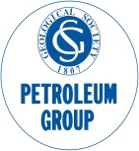
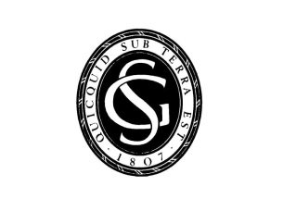
The Geological Society of London
Eastern Mediterranean – An emerging major petroleum province
29-30 May 2018
The Geological Society, Burlington House, Piccadilly, London

Personal Details

Title:
First Name: |  |  | Surname:
Company:
Address:
Postcode: |  | Tel No:
Email: |  | Fellowship Number (if applicable):

Registration Fees (Please Circle)

Hot Fork Buffet | £25.00

Payment Details

 | I enclose a cheque for £ |  |  | made payable to the Geological Society
 | Please debit my Visa/Master/Amex/Switch card by the sum of £
 | Card Number: |  |  |  |  |  |  | Expiry Date:
 | Security Number (last 3 digits on black strip on back of credit card):
 | Start Date/Issue Number (Switch only)

Signature:_____________________________________________ Date:_________________

How did you hear about this event (please circle):

GSL website Email Poster Geoscientist Other (please state) ___________________

General Information

Full prepayment must accompany your registration form to guarantee a place. Student ID will be required. An email confirmation letter will be sent to you on receipt of your completed registration form. A receipt may be issued on request. Notification of cancellation must be given at least 10 working prior to the event for a full refund to be given.

We would like to keep you informed about future meetings and other Society activities. Please tick here if you would like to receive such information

Please return this form to: Sarah Woodcock, Conference Office, Geological Society, Burlington House, Piccadilly, London, WIJ OBG. Tel: +44 (0) 20 7434 9944 Email: sarah.woodcock@geolsoc.org.uk

